
Sec 7.4 – Hamilton Circuits & Paths
Networks & Graphs Name:
- Hamilton looked at the ‘graph puzzle’ from a slightly different perspective. He asked if it was possible to traverse the graph and pass through each vertex only once. Again similar to Euler, the graph is consider to have a Hamilton Circuit if you can end at the same vertex you started with and a Hamilton Path if you start and end on different vertices. Circle each graph below that you think has a Hamilton Circuit and put a square around each that you think has a Hamilton Path.
A
A
•
•
•
•
•
•
•
•
•
•
•
E
E
A
•
•
•
•
•
•
B
F
D
F
B
D
C
C
B
E
C
D

E
B
A
E
F
D

D
A
C
C
B

- Find a HAMILTONIAN CIRCUIT of the graph below (Give a sequence of letters to describe the path (e.g. A, D, E, B, ……….. etc.))
- Find a HAMILTONIAN PATH of the graph below (Give a sequence of letters to describe the path (e.g. A, D, E, B, ……….. etc.))

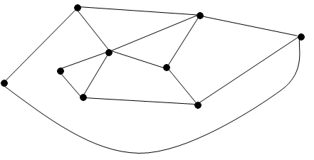
A
B
C
D
E
F
G
H
I

J
A
B
C
D
E
F
G
H
I
•
•
•
•
•
•
•
•
•
•

Student Worksheets Created by Matthew M. Winking at Phoenix High School SECTION 7-4 p.92

